

1.

%% Fourier Series Solution f(t) = 1 when −pi ≤ 𝑡 ≤ 0 And f(t) = 0when 0 ≤ 𝑡 ≤ pi

clear;

t = [-pi:0.1:pi]; % create time points in plot

f =ones(size(t)); % initialize function f(t)

for k = 1:length(t) % construct function f(t)

if t(k) < 0; f(k) = 0; else f(k) = t(k); end;

if t(k) < -pi; f(k) = t(k) + 2*pi; end;

if t(k) > pi ; f(k) = 0; end;

end

% initialize Fourier series with the mean term

fs = (pi/4) * ones(size(t));

clf % clear any figures

for n = 1:6

% create plot of truncated FS with only n harmonic

fs = fs - (2/pi) * cos((2*n-1)*t) / (2*n- 1)^2;

fs = fs - (-1)^n * sin(n*t) / n;

subplot(3,2,n), plot(t,fs,t,f,'--')

if n==1

legend('mean plus 1 term','f(t)'); legend boxoff;

else

legend(['mean plus ',num2str(n),' terms'],'f(t)')

legend boxoff

end

if n >= 5; xlabel('t'); end;

end

Output:

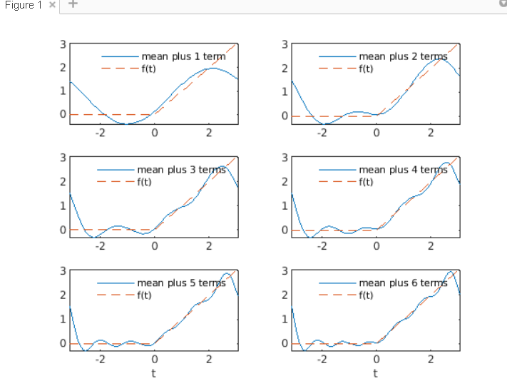

**2.**

**%% Fourier Series Solution f(t) = 0**

**when −pi ≤ 𝑡 ≤ 0 And f(t) = t when 0 ≤ 𝑡 ≤pi/ 2 And f(t)=pi-t when pi/2 ≤ 𝑡 ≤pi**

**clear;**

**t = [-pi:0.1:pi]; % create time points in plot**

**f = zeros(size(t)); % initialize function f(t)**

**for k = 1:length(t) % construct function f(t)**

**if t(k) < 0; f(k) = 0;**

**else f(k) = t(k); end;**

**if t(k) < -pi; f(k) = t(k) + 2*pi; end;**

**if t(k) > pi ; f(k) = 0; end;**

**end**

**% initialize Fourier series with the mean term**

**fs = (pi/2) * ones(size(t));**

**clf % clear any figures**

**for n = 1:6**

**% create plot of truncated FS with only n harmonic**

**fs = fs - (2/pi) * cos((2*n-1)*t) / (2*n- 1)^2;**

**fs = fs - (-1)^n * sin(n*t) / n;**

**subplot(3,2,n), plot(t,fs,t,f,'--')**

**if n==1**

**legend('mean plus 1 term','f(t)'); legend boxoff;**

**else**

**legend(['mean plus ',num2str(n),' terms'],'f(t)')**

**legend boxoff**

**end**

**if n >= 5; xlabel('t'); end;**

**end**

**Output:**

